**AWT Practical *Week - 5 Task***

**Form Submission (GET & POST Methods)**

1. Get the data from user registration form(With all HTML form controls) and display it in tabular format.(Create responsive frontend and validate using JavaScript)

**Code:**

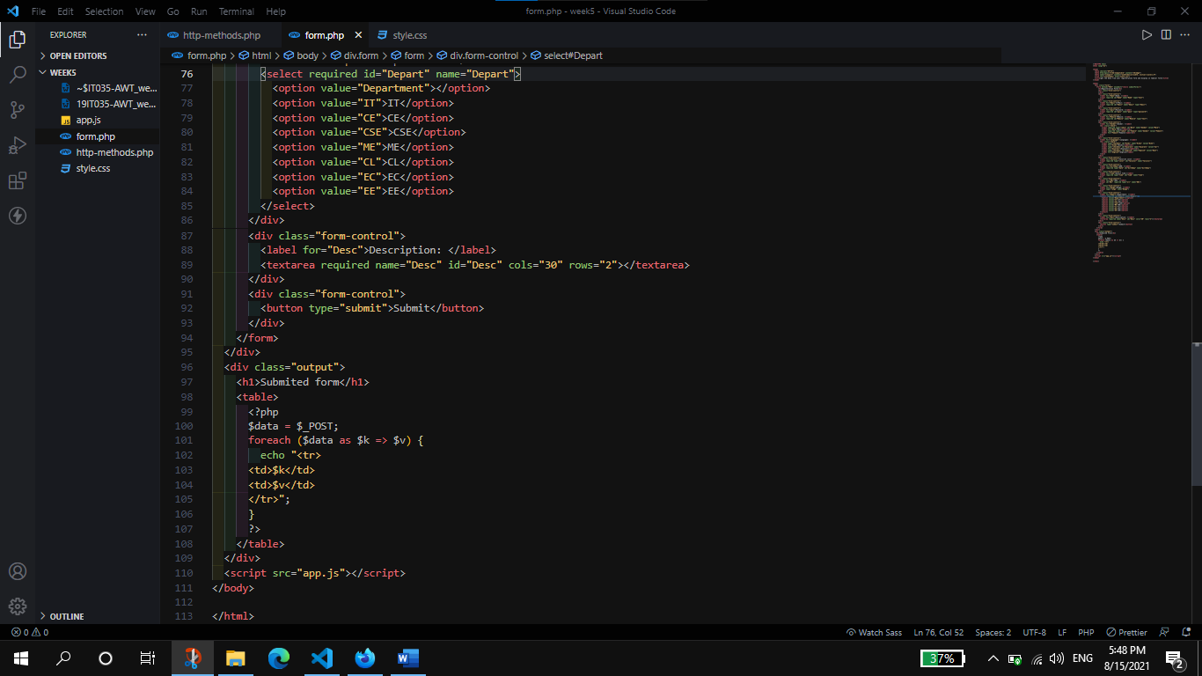

**Output:**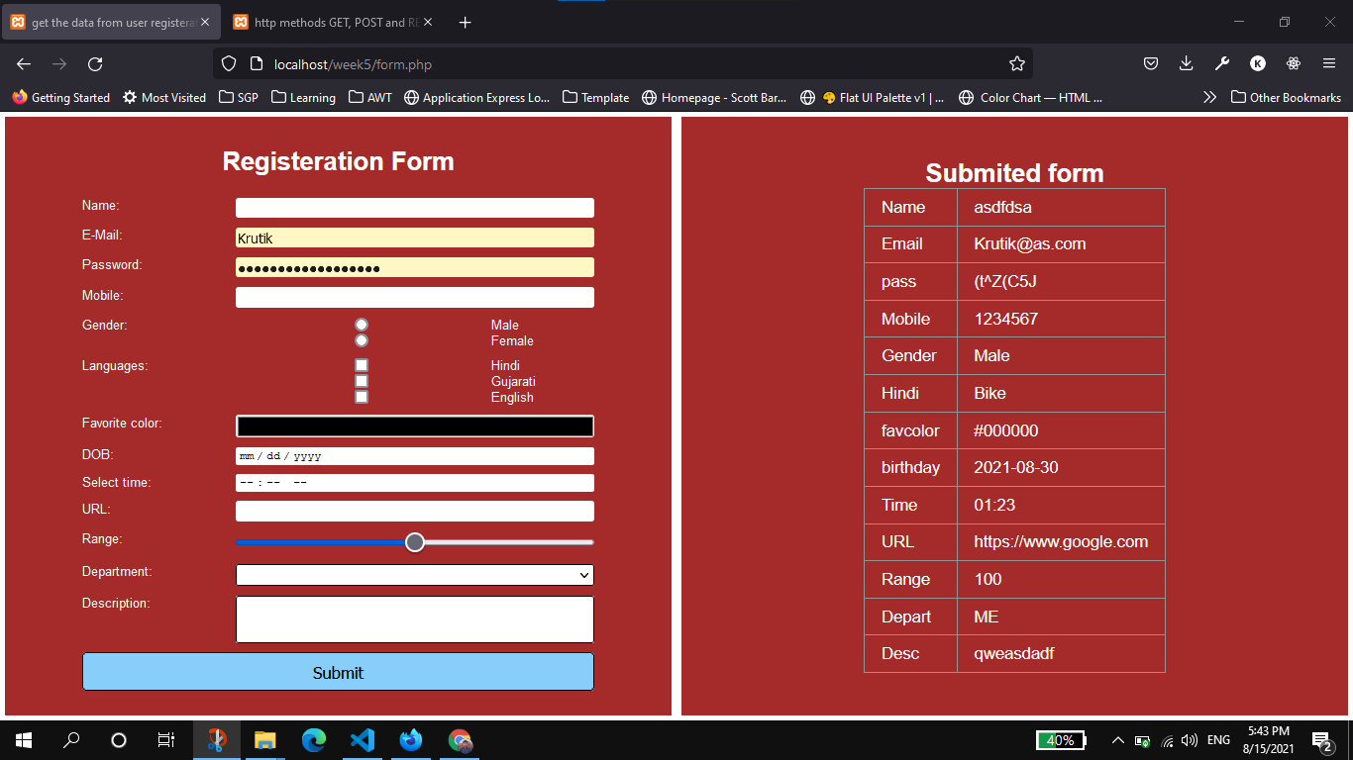

1. Demonstrate HTTP methods(GET, POST, REQUEST).

**Code:**

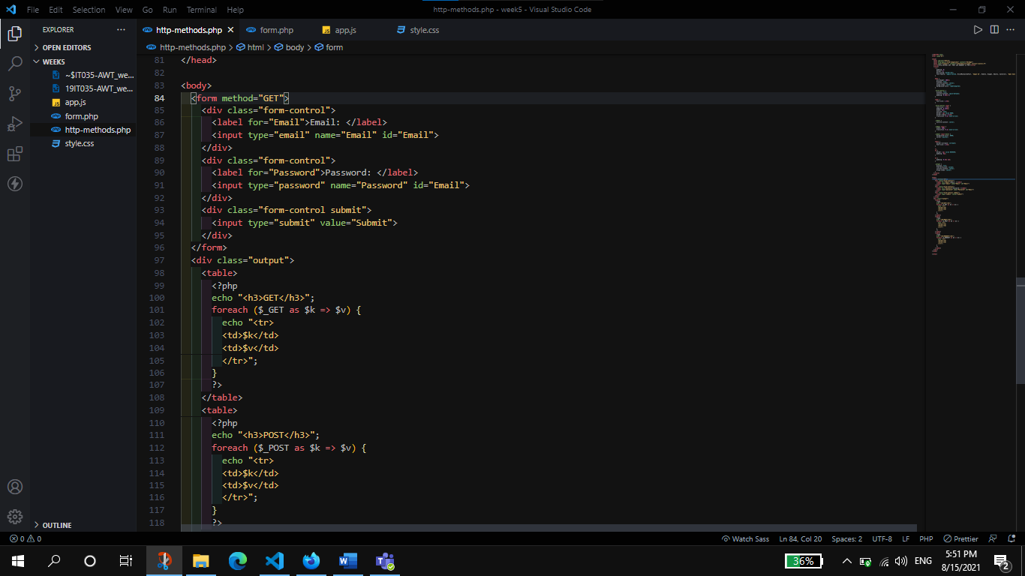

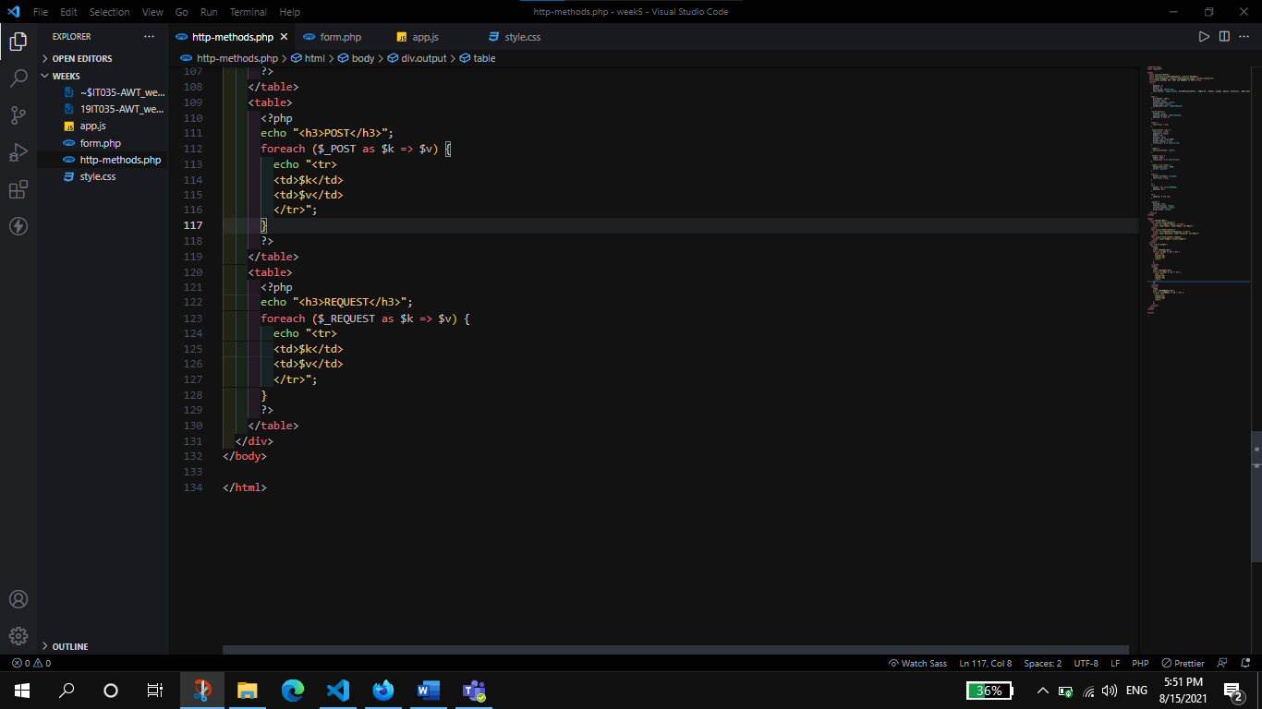

**Output:**

GET method Output:

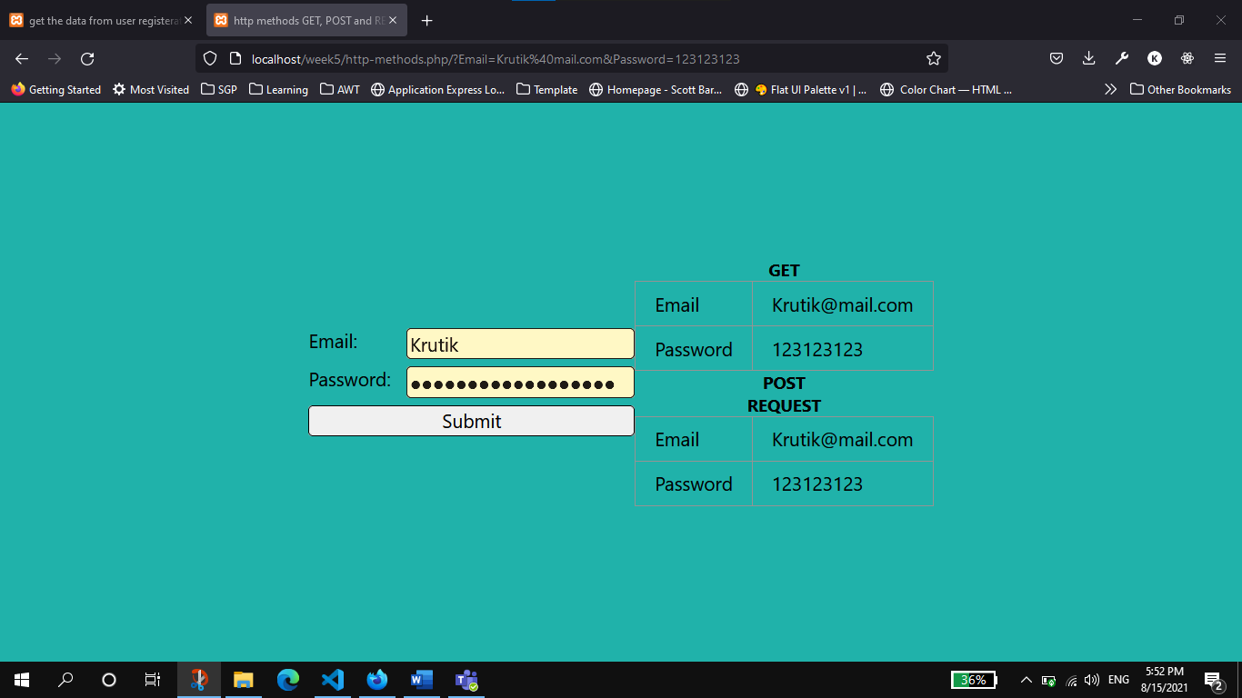

POST Method Output:

